The Canadian Geological Landscape

Part #1 Geological Time Periods

What do you remember of geography from Socials 9? (5 minutes)

How many geological time periods are there in Canada? 1 2 3 4 5 6

Name a FEW Pre-Cambrian characteristics
- __________________________________________________
- __________________________________________________
- __________________________________________________

Name a FEW Paleozoic characteristics
- __________________________________________________
- __________________________________________________
- __________________________________________________

Was this the time period for when life started? Yes No

Name a FEW Mesozoic characteristics
- __________________________________________________
- __________________________________________________
- __________________________________________________

Was this the time period for the dinosaurs? Yes No

Name a FEW Cenozoic characteristics
- __________________________________________________
- __________________________________________________
- __________________________________________________

Part #2 Geological Rocks

Igneous Rocks are formed from lava Yes No
Why? _______________________________________________________________________

How does igneous rocks form from lava? __________________________________________

____________________________________________________________________________

What physiographic region in Canada is comprised mainly of igneous rocks? _______________

Are metamorphic rocks really hard? Yes No
Why? ________________________________________________________________________

Name a FEW of the minerals that are found deep inside metamorphic rocks
  - __________________________
  - __________________________
  - __________________________

They are formed as a result of a massive amount of he_____________ and ______________ over ____________________ of years.

Why is this important to the Canadian economy?

____________________________________________________________________________

____________________________________________________________________________

What makes a sedimentary rock different from the other two types of rocks?

____________________________________________________________________________

____________________________________________________________________________

____________________________________________________________________________

Are sedimentary rocks weaker than the other two rock types? Yes No
Why? ________________________________________________________________________

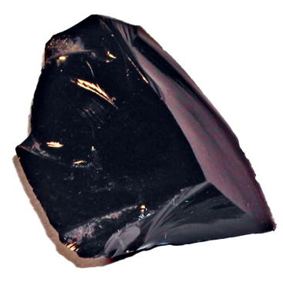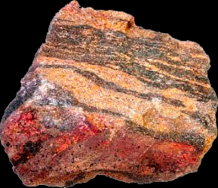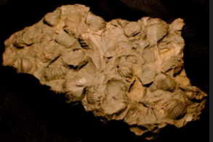

Part #3 Physiographic Regions of Canada

Which region is found in the very far north? ______________________________

Name a FEW characteristics of this region.
- _____________________________________________________
- _____________________________________________________
- _____________________________________________________

Does this region include the Treeline? Yes No

What does the land look like? __________________________________________________

__________________________________________________________________________

Name a COUPLE of characteristics of the Arctic Lowlands region.
- _________________________________________________________
- _________________________________________________________

Name a COUPLE of characteristics of the Western Cordillera region.
- _________________________________________________________
- _________________________________________________________

Name a COUPLE of characteristics of the Interior Plains region.
- _________________________________________________________
- _________________________________________________________

Name a COUPLE of characteristics of the Canadian Shield region.
- _________________________________________________________
- _________________________________________________________

Name a COUPLE of characteristics of the Hudson Bay Lowlands region.
- _________________________________________________________
- _________________________________________________________

Name a COUPLE of characteristics of the Appalachian Mountains region.
- _________________________________________________________
- _________________________________________________________
Name a COUPLE of characteristics of the St. Lawrence Lowlands region.
- __________________________________________________________
- __________________________________________________________

